INFO 6055

Non-Functional Testing In Class Assignment – In Class 10

## Description – Perform a load Test using JMeter

Marks - 40

Instructions

Set up your test environment

1. In this exercise, we are going to use an application “attic2” which we have used earlier. This project should be available under your tomcat\webapps directory.
2. Start Tomcat
3. In your browser navigate to localhost:8080/attic2/

Understand how to setup your test

1. Key in F12 command from your keyboard for launching chrome developer tool. From Network options check “Preserve log” option.
2. Manually enter required information in attic2 form and click on submit button.

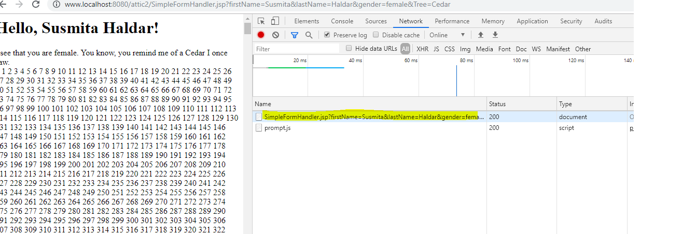

1. Now from chrome developer tool, click on the link available in the left side of the window.

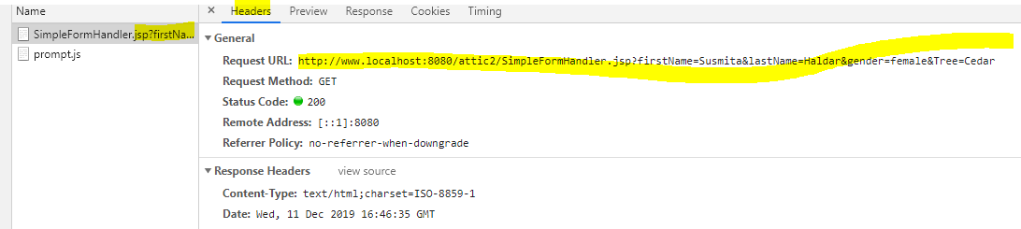

1. Click on the header tab. Verify the Request URL section and Query String Parameters section that will be important for the next part of your test when you are going to create your test in JMeter

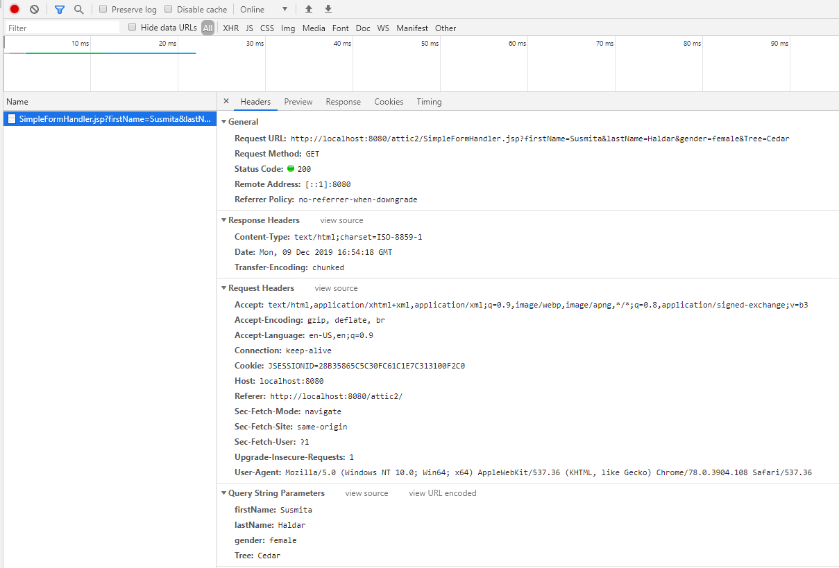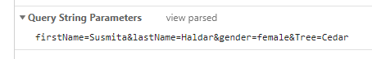

1. Note down the query string parameters. Each of these parameters are case sensitive, and you need to pass them to the string exactly the way they are. You will use CSV download element for parameterizing your test with passing these input parameters from a CSV file that will create for your JMeter test plan.

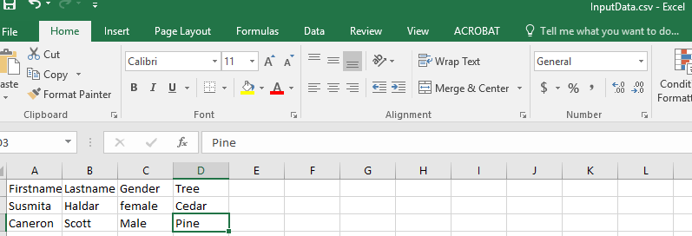

Open an excel file, and put multiple rows with firstname, lastname, gender and Tree. Save this file as CSV comma delimited CSV file option in a folder that you can navigate to later

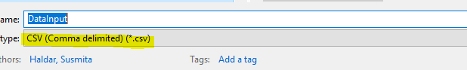

Now you are set to start creating your test plan in JMeter

In JMeter, click on Template, and select “Building a WebTestPlan” template. In Http Request Default request, make the following modifications:

Set the server name or IP address to localhost

Set port 8080.

Now,

Click on “Home Page” request, and add /attic2/ in the path. Change the assertion to the text that is applicable for your request.

When changing the assertion text, consider that you are expecting to see the following page when you are navigating to the homepage:

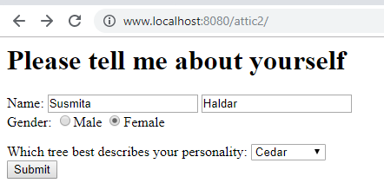

Next, create a new http request, and rename this request to “Submit Form”.



Add the path or URL from the preserved log that you used during your manual analysis:

The objective of this part of test is we will attempt to add data to the form using parameter driven variable.

Copy the URL up to the question mark. The remaining text after the question mark is used for submitting parameters, which we are going to do through our CSV data input file. The parameters will be added separately using the add option which is described in the next page.

As a result, in the path field of the submit_form request, you can just put /attic2/SimpleFormHandlar.jsp. The server name will be coming from Http Request Default request.

Now right click on submit_form request, and select

Add->Config Element ->select CSV Data Set Config

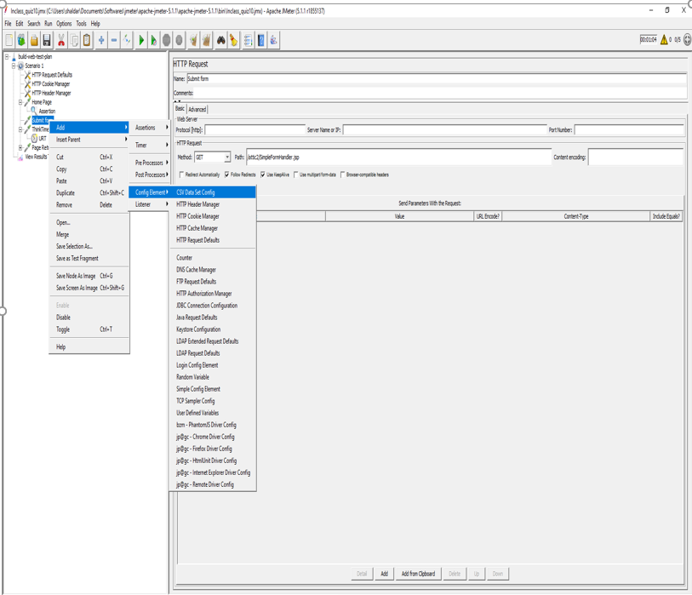

Now, click on CSV Data Set Config request that you just created. Click on “Browse” for navigating to the path of your InputData.csv file.

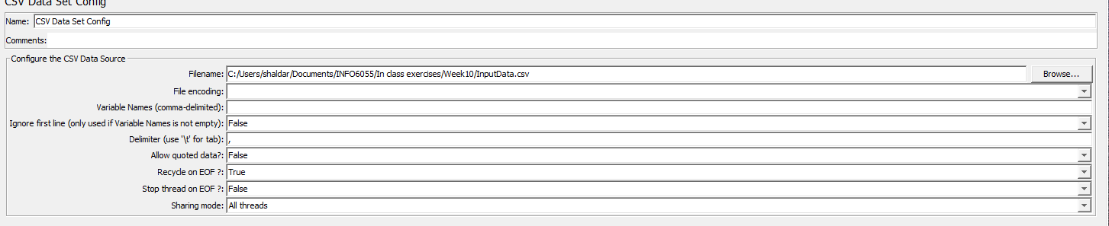

If you have provided the variable names in the CSV file, you need to change the “Ignore first line” to true.

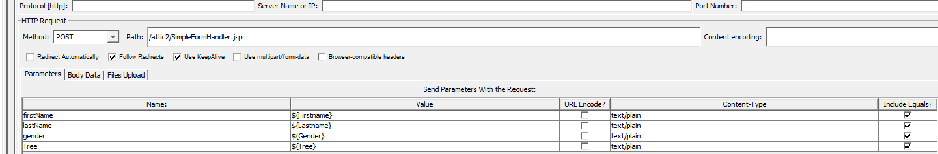

Next, click on submit_button form, and click on add button to add parameters for this test. Change the method name from get to post. The Name field in the Parameters list need to match with the name in the query parameters list that you noted before. This field is case sensitive. On the other hand, the value field is coming from your excel file, and the value needs to match with the variable name that you have used in your csv file.

Add other listeners that will assist you with interpreting your test results.

Modify the Assertion_404 page to Assertion_200 instead since with our request to homepage we are expecting a success response with response code of 200.

Change the path in this page to /attic2/

Change the response code in Assertion_200 to 200.

Save your test.

Test for load, start with 1 user and increase.

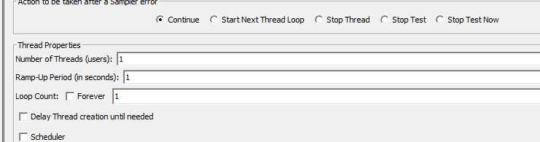

Verify what is shown in the request and response section of your result tree. Provide a screenshot. You change the representation from text to html.

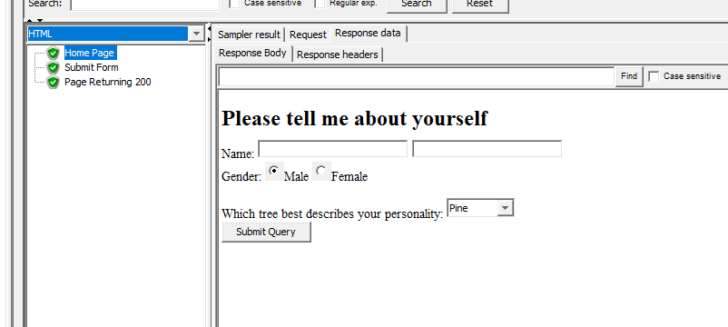

1. Find the peak for your system.
2. When you have completed your test.
3. Provide a screenshot of your test setup.
4. Answer the questions.

You must submit

This document with screenshots and answer?

Do not zip anything.

Marking Scheme:

|  |  |  |
| --- | --- | --- |
| **Marks Available** | **What Are the Marks Awarded For?** | **Marks Awarded** |
|  | | |
| **10** | **Define a proper JMeter test – used the tool correctly** |  |
| **15** | **Answers to questions** |  |
| **5** | **Test Result (Listeners) supports your answer user capacity value** |  |
| **5** | **Supporting screenshots** |  |
| **5** | **Your conclusion** |  |
| **___ 40** | **TOTAL MARKS** |  |

SCREENSHORTS :

TEST WITH ONE USER

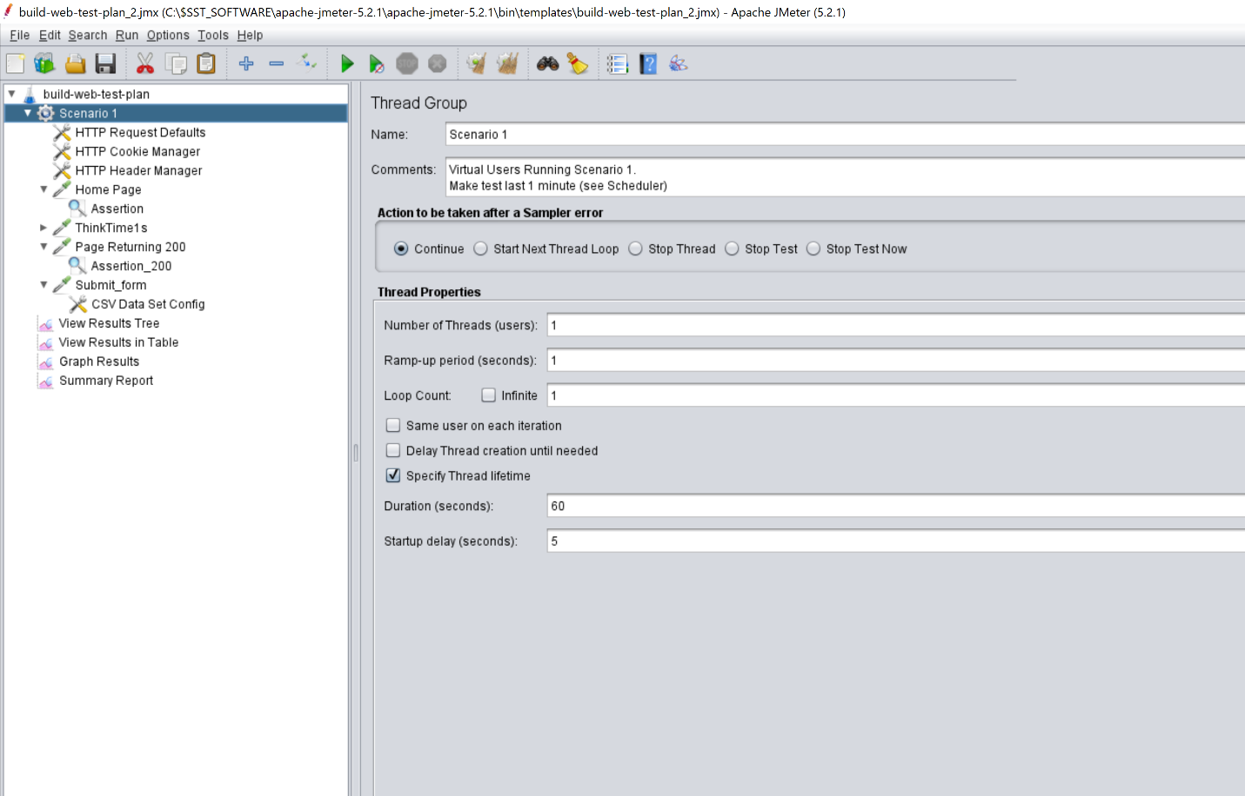

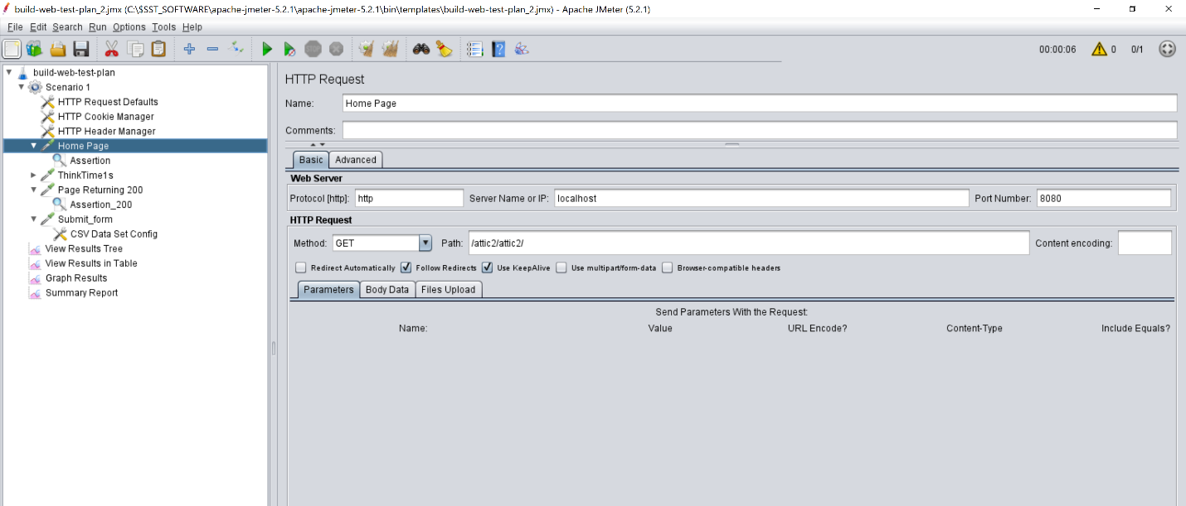

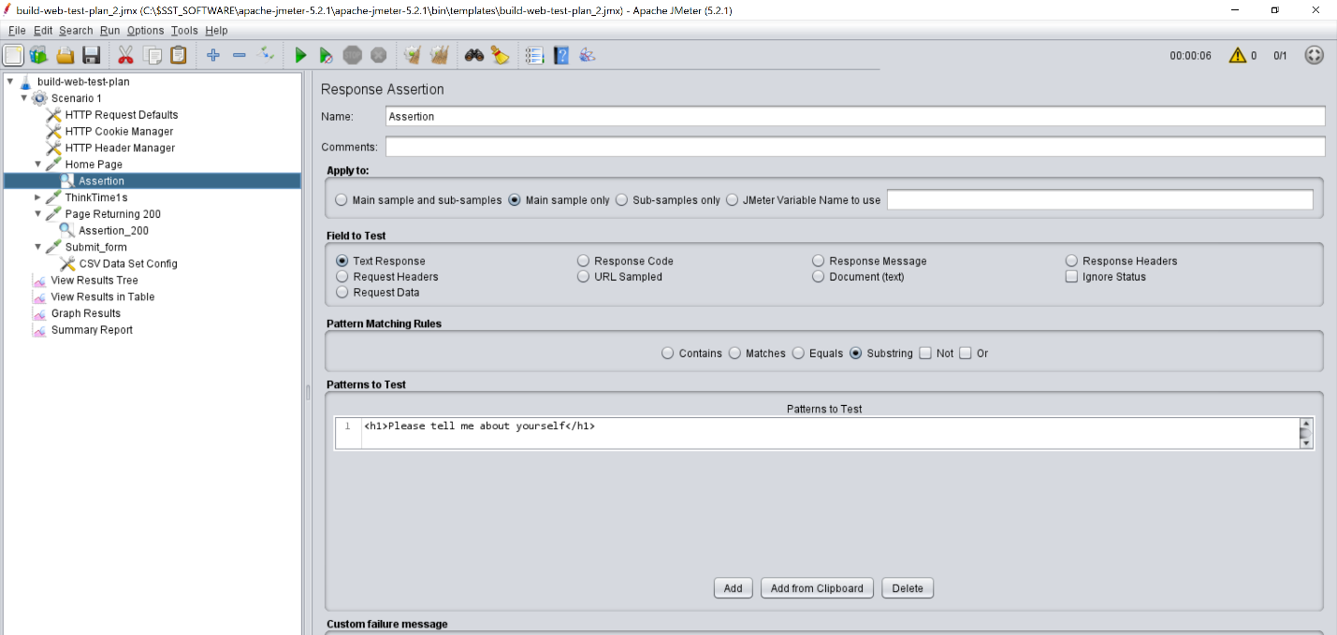

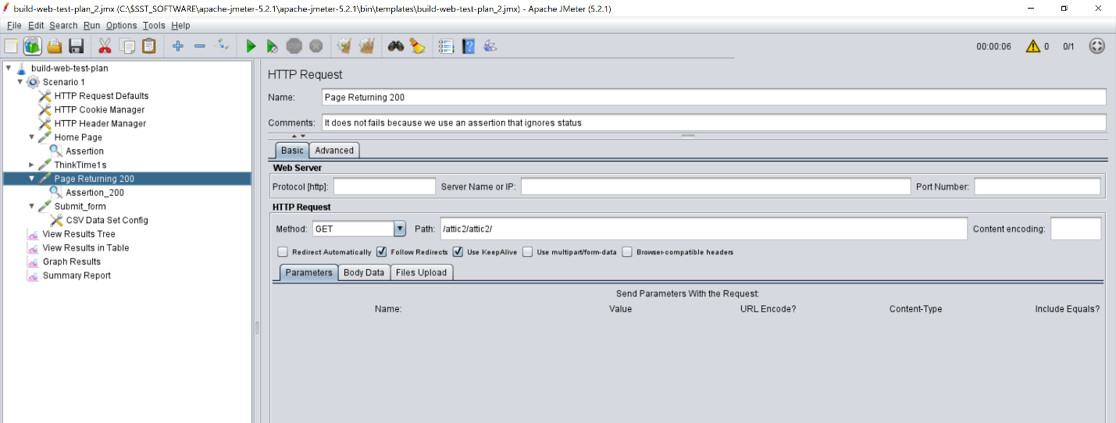

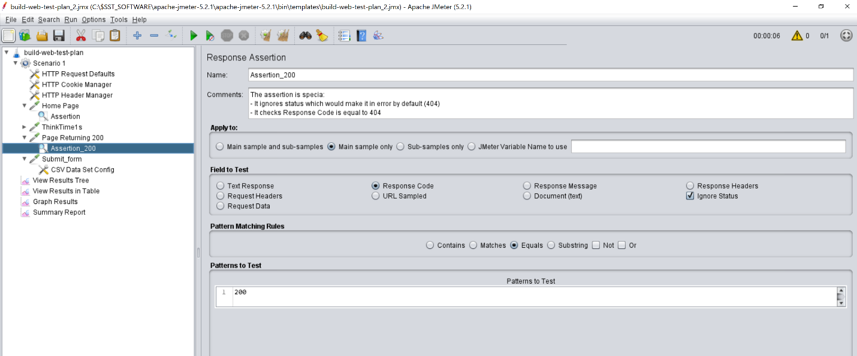

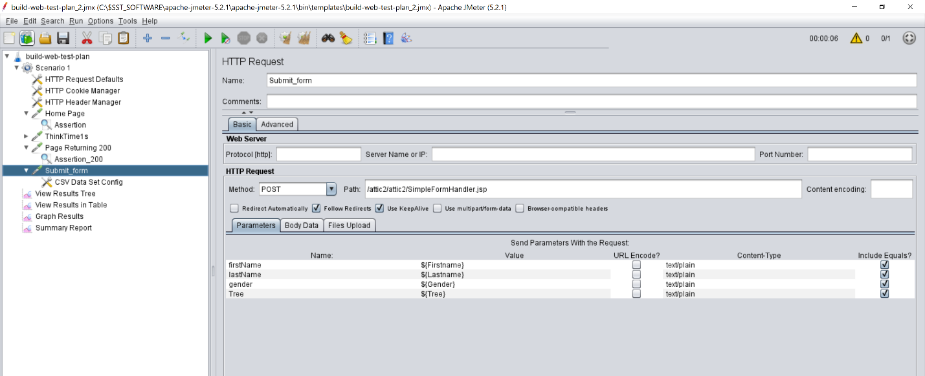

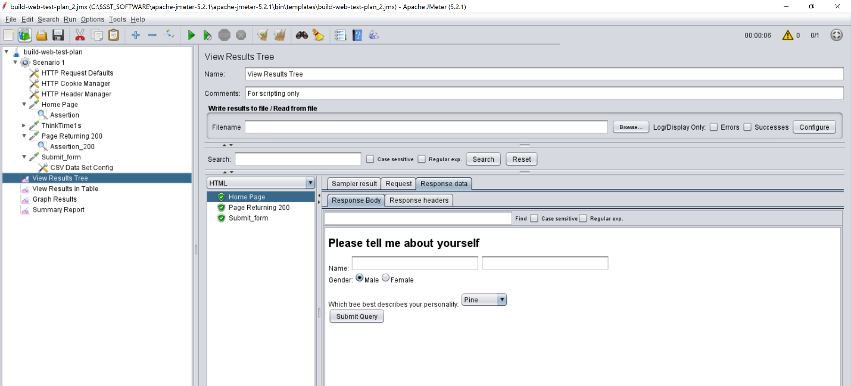

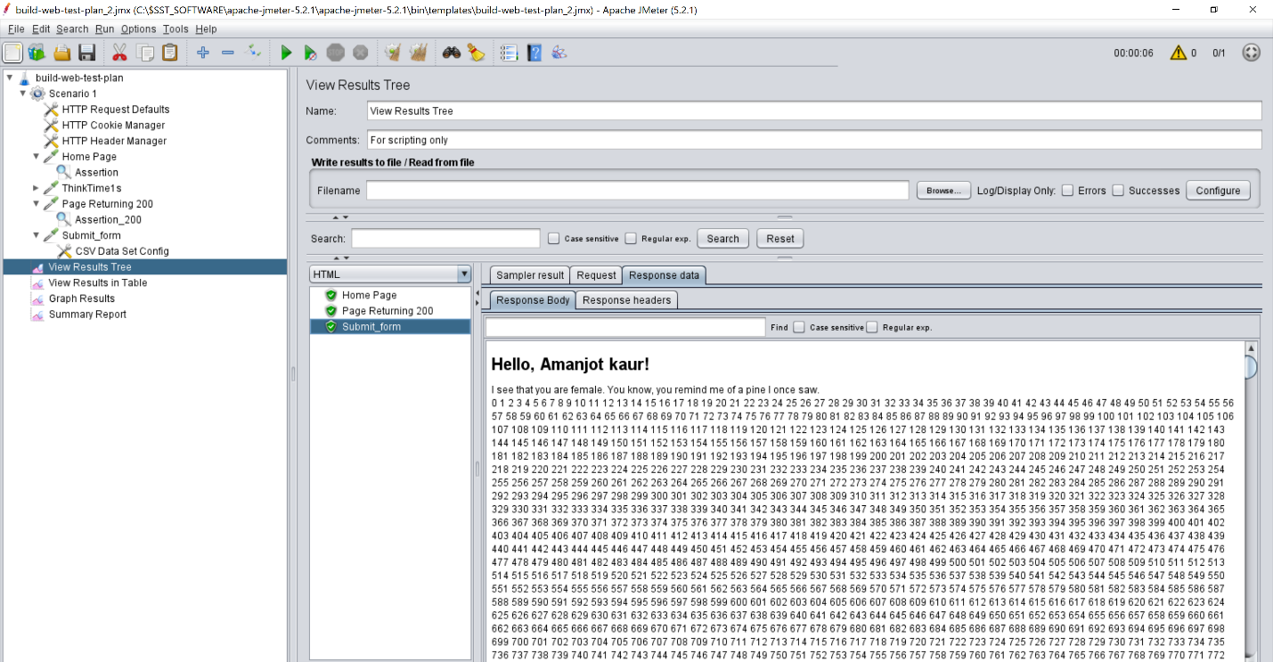

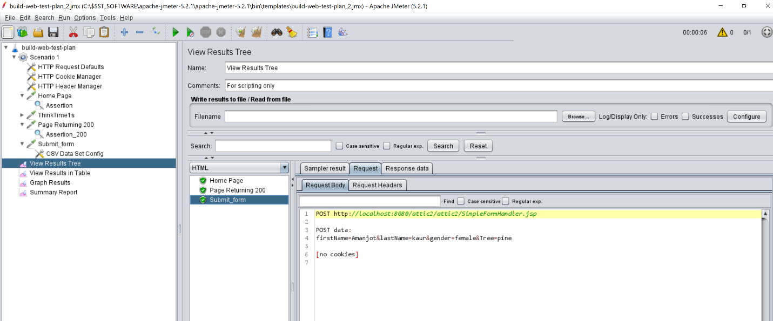

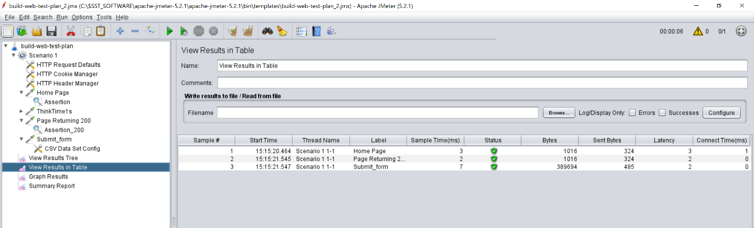

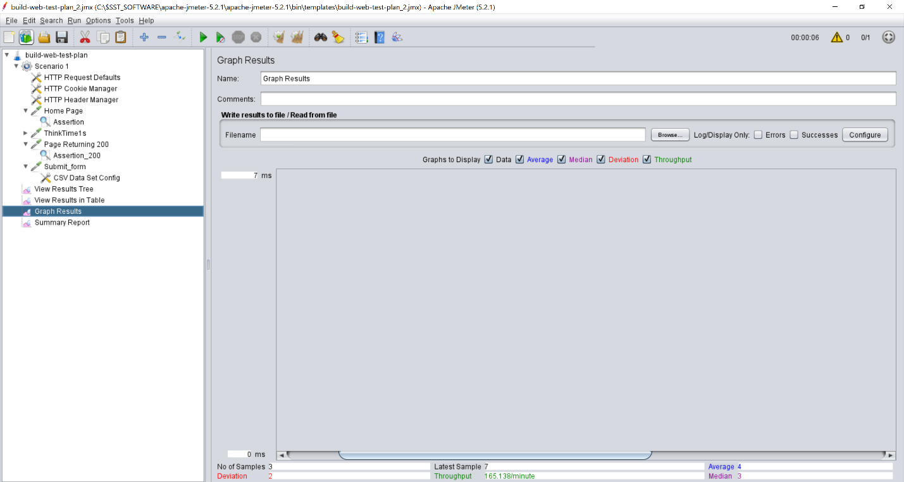

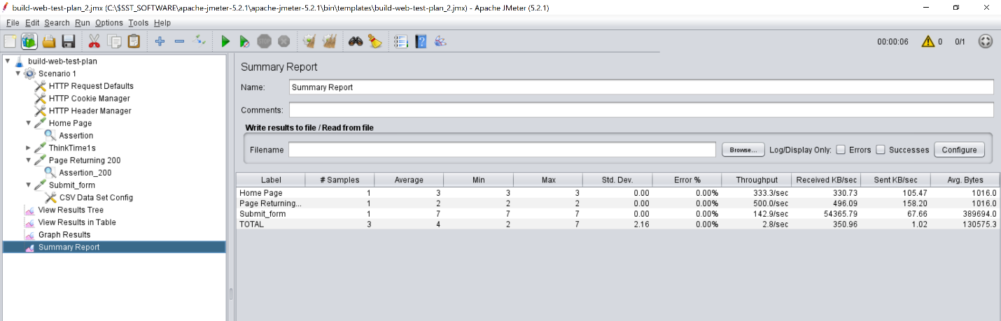

**Questions**

1. How many users can your system support before the request time increases significantly? Provide Screenshot of each of the requests

Ans : System give red sign after sampler no. 29,091 as shown below in screenshots, technically one request has three requests which means :

For ten thousand users, total samplers are 10,000* 3 = 30,000.

If sampler fails at 29,000 sampler , it means system support 29,091 / 3 = 9,697 or 9000 users approximately.

THREAD WITH 10,000 THREADS

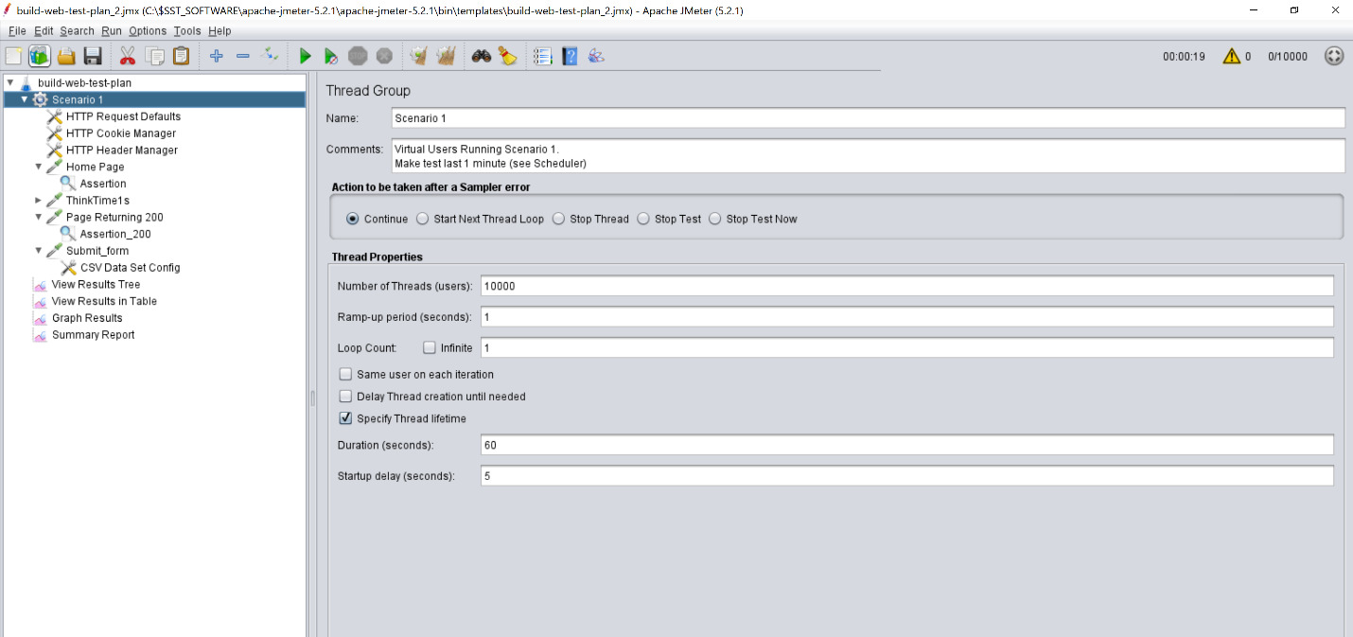

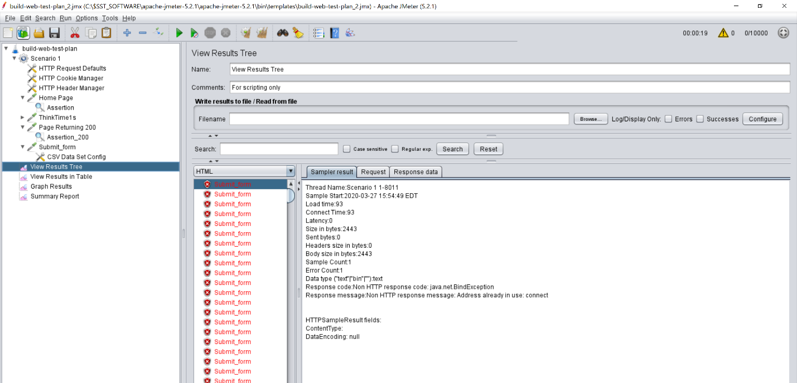

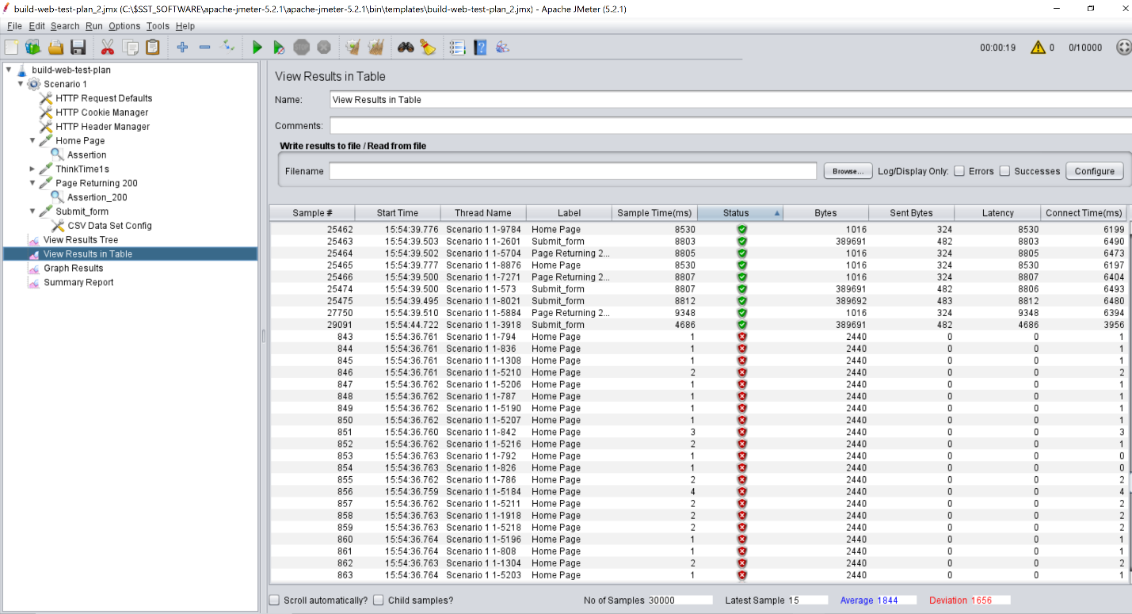

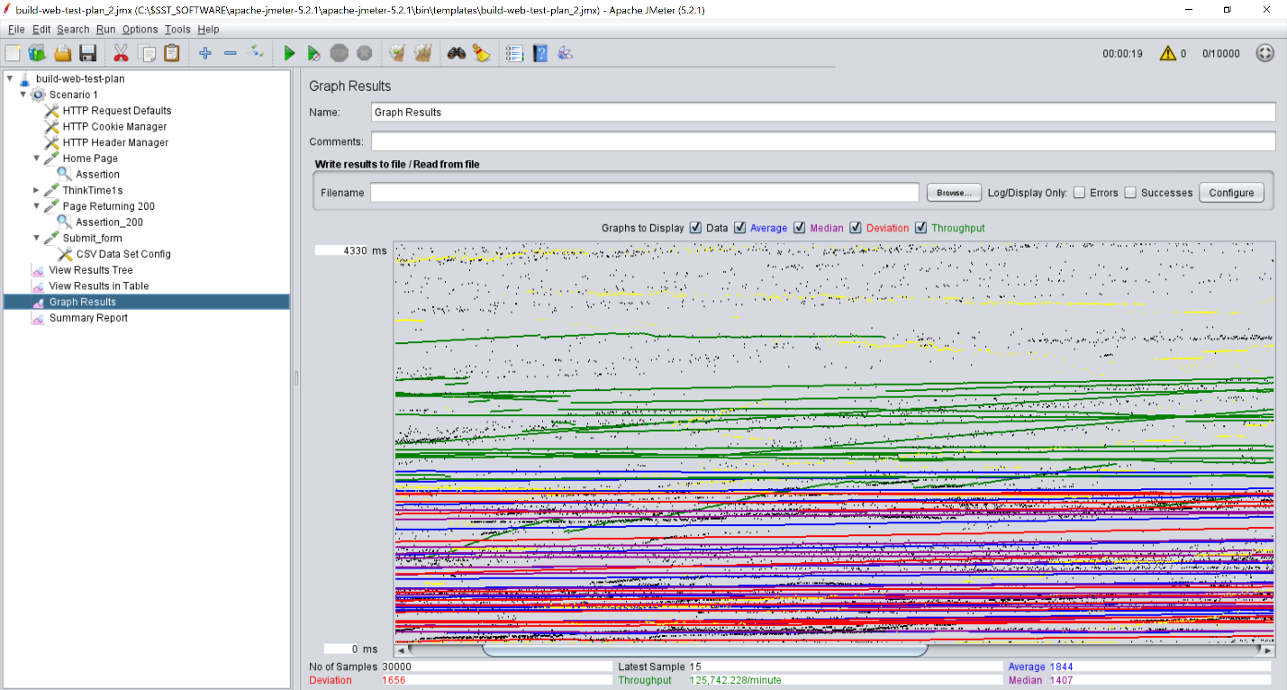

1. List the specific metrics and the values you viewed to derive your answer above. (use screenshots if necessary)

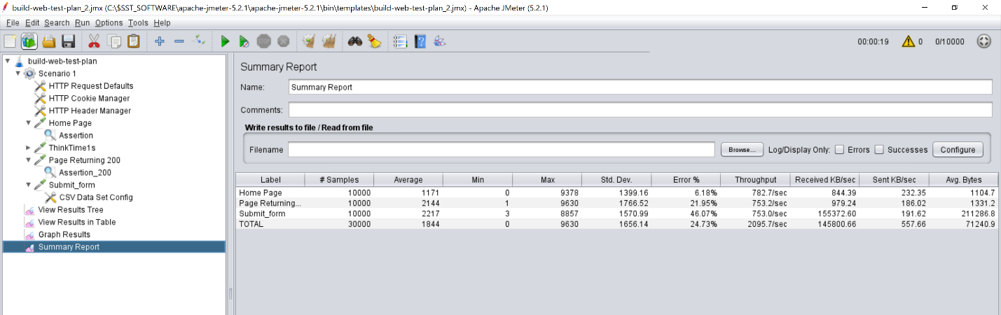

Various metrics used are : Average, Min value , max value, Standard deviation, Error percentage, Throughput, Average bytes, and received and sent in KB/sec.

1. What other conclusions can you see based on the values of the metrics you collected?

It is concluded that most of the Errors are faced by Submit page form due to heavy load as compare to Home page. With an average of approximately 21,000 bytes , submit form also uses highest bytes.All other metrics also goes parallel with each other including throughput, standard deviation as shown in above graph. As user increases, load gets increase, due to which various processes are busy and shows fail status in between the sequence.